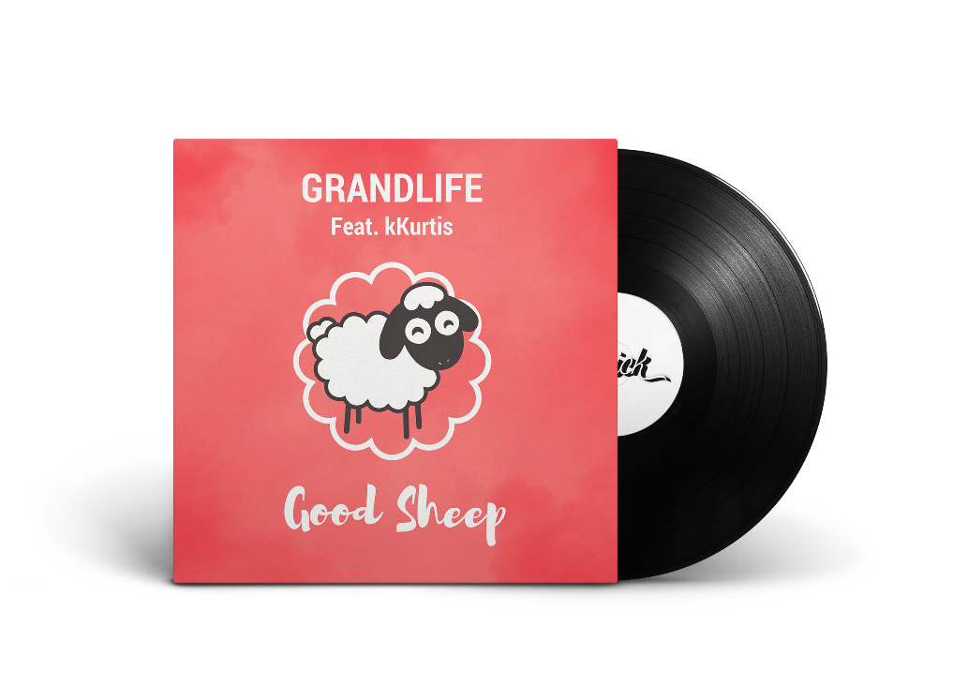
GRANDLIFE – Good Sheep (feat. kKurtis)
Grandlife Socials:
Facebook
Soundcloud
Spotify

Release Information
Label : Sidekick Music
Cat N° : SIDE012
Release Date : February 21st , 2018
Pitch
FRANCE based GRANDLIFE has made remix appearance on NAPKEY's Last Thoughts, counting plays in millions. After sharing a Kitsuné release he most recently gathered strong Spotify support with "Backdown". Keen to bring the groove back as the main asset of electronic music:
"Good Sheep" is a fun & fresh Nu Disco record with the delightful performance from kKurtis,
Highlighting both sides of what we’re made of.
Facts/Anecdote:
Before discussing the record, both Grandlife & kKurtis didn’t know they actually grew up in the same city of Toulouse, France.

